**Preprocessing the REST return data:**

Import map: from rxjs

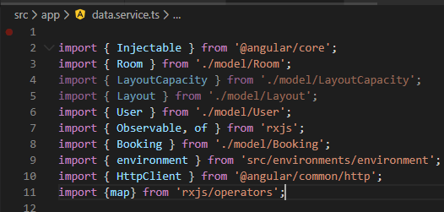

Implement preprocessing: or pipe()

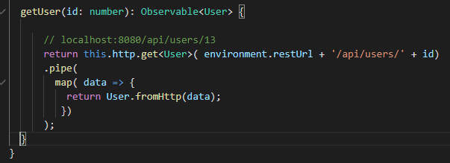

Test for User objects with browser:

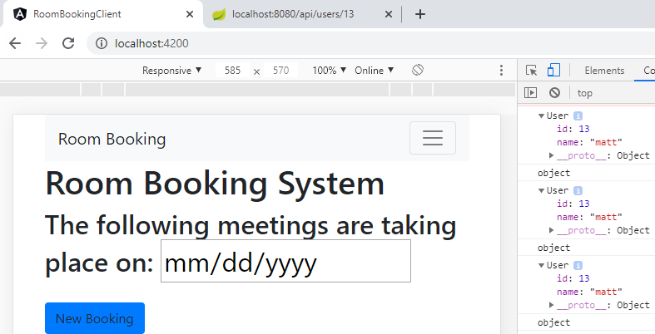

Now, we can remove code:

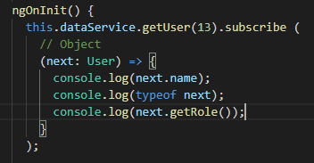

Test again:

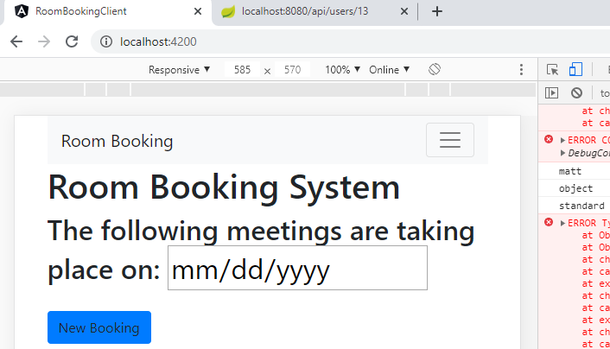

Looks the same, good!

**Optional calling a REST endpoint Exercise:**